**LIBRARY MANAGEMENT SYSTEM**

**Abstract**

The Library Management System (LMS) is designed to facilitate efficient management of library operations using a user-friendly graphical interface. Developed with Python's Tkinter library and SQLite, the system automates book issuance, returns, and transaction tracking. It features functionalities for searching transactions based on various criteria, enhancing the efficiency of library management. The system provides a streamlined approach to managing books and member interactions, reducing manual effort and improving accuracy.

**Introduction**

Library Management Systems are essential for modern libraries to handle a large volume of books and member interactions efficiently. Traditional methods often involve cumbersome paperwork and manual tracking, leading to errors and inefficiencies. This project presents a Library Management System developed using Python’s Tkinter for the graphical user interface and SQLite for data management. The system aims to simplify library operations by automating the issuance and return of books, tracking transactions, and providing a robust search functionality. This application is intended to support library staff in managing resources effectively and enhancing user experience.

**Literature Review**

1.Title:"Development of Library Management System using Java Swing and MySQL"

Authors: Hassan, M. A., & Khatun, S.

Abstract: This paper presents a library management system developed using Java Swing for the graphical user interface (GUI) and MySQL for database management. The system is designed to automate common library operations such as book issuance, returns, and catalog management. It highlights the challenges and solutions encountered during the development process, including issues related to data synchronization and user interface design. The system aims to improve the efficiency of library operations and reduce manual errors, providing a more streamlined experience for both library staff and patrons.

2.Title:"Automated Library Management System: A Study"

Authors: Garg, A., & Bansal, A.

Abstract: This study explores various automated library management systems and their implementations. It provides a comprehensive review of different technologies and platforms used for creating library management systems, including their features and functionalities. The paper discusses the benefits of automation in library management, such as increased efficiency and accuracy in handling transactions. It also examines the limitations and potential improvements of existing systems, offering insights into the future development of library management technologies.

3.Title:"Design and Implementation of a Library Management System Using PHP and MySQL"

Authors: Sharma, V., & Gupta, R.

Abstract: The paper details the design and implementation of a library management system utilizing PHP for the server-side scripting and MySQL for the database. The system is intended to manage library operations such as book inventory, member registration, and transaction processing. The authors describe the system architecture, including the interaction between the user interface and the database. They also discuss the challenges faced during development and the solutions applied to address issues related to data integrity and user authentication.

4.Title:"Library Management System: A Review"

Authors: Kumar, R., & Sharma, P.

Abstract: This review paper provides an analysis of various library management systems available in the market. It focuses on the features, performance, and user feedback of different systems, comparing their strengths and weaknesses. The paper highlights key aspects that contribute to effective library management, such as user interface design, data handling capabilities, and integration with other systems. It also explores emerging trends and technologies in the field of library management, offering recommendations for future improvements

**Objectives of My Project**

i. **Efficient Book Management**: Implement a system that allows the easy addition, updating, deletion, and viewing of books in the library database.

ii. **Member Management**: Develop functionality to manage library members, including adding new members, updating existing member details, and deleting members.

iii. **Transaction Recording**: Create a system to accurately record the issuance and return of books, including tracking the status of each transaction.

iv. **Search and Filter Capabilities**: Provide robust search options for users to locate books and transactions by various criteria, such as member ID, book ID, and date ranges.

v. **User-Friendly Interface**: Design an intuitive and accessible interface using Tkinter, making it easy for library staff to navigate and perform necessary tasks.

vi. **Data Integrity and Validation**: Ensure that data entered into the system is validated and consistent, preventing errors in transactions and member management.

vii. **Database Integration**: Seamlessly integrate with an SQLite database to store and retrieve information, ensuring data is securely and efficiently managed.

viii. **Scalability and Maintainability**: Design the system architecture to allow for future enhancements and maintenance, making the system adaptable to the library’s growing needs.

**Proposed System**

The proposed system is a comprehensive Library Management System designed to streamline and automate the core operations of a library. Developed using the Tkinter library in Python for the graphical user interface and SQLite for database management, the system aims to provide an efficient and user-friendly platform for managing library resources, members, and transactions.

**Key Features:**

**i. Book Management:** Allows library staff to add, update, delete, and view book records, including details such as book title, author, publication year, and ISBN. Ensures that all book data is accurately stored and easily retrievable.

**ii. Member Management:** Facilitates the registration of new members and the management of member information. Enables updating and deleting member records as needed.

**iii. Book Issuing and Returning:** Provides functionality for issuing books to members and recording the transaction in the database. Includes features for tracking due dates and returning books, with automated updates to the book's availability status.

**iv. Transaction Search:** Implements a search feature to retrieve transaction histories based on member ID, book ID, or date range. Helps staff efficiently monitor and manage book loans and returns

**v. Data Integrity and Validation:** Utilizes SQLite database constraints and application-level checks to ensure data integrity prevents duplicate entries and ensures that only valid data is stored.

**System Architecture:**

The system architecture of the Library Management System is designed to facilitate seamless interaction between the user interface and the underlying database, ensuring efficient management of library resources. The architecture is structured into several key components, each serving a distinct purpose:

1. **Login and Registration Page**: This module serves as the entry point to the system, where users (both library staff and members) can log in or register. The login system ensures that only authorized personnel can access administrative functions, maintaining the security and integrity of the library's data. The registration functionality allows new users to create accounts, ensuring that all interactions with the system are linked to a verified user profile.
2. **SQLite3 Database**: The system uses SQLite3, a lightweight yet powerful relational database, to store and manage all data related to books, members, and transactions. This database is integrated with the system, providing a robust backend to handle various operations such as data insertion, updating, deletion, and querying. The database consists of multiple tables, including those for books, members, and transactions, which are linked through foreign key relationships to ensure data consistency and integrity.
3. **Book Management Module**: This module allows library staff to manage the library's collection of books. Functions include adding new books, updating existing book details, deleting books that are no longer available, and viewing the current inventory.

The module interacts with the database to perform these operations, ensuring that the book records are always up-to-date and accurate.

1. **Members Management Module**: This module is responsible for managing library members, including adding new members, updating member information, deleting inactive members, and viewing member details. It ensures that the library has a complete and accurate record of all members, which is essential for issuing and returning books, as well as for maintaining contact with members.
2. **Issue or Return Books Module**: This module facilitates the core function of any library: issuing books to members and processing their return. When a book is issued, the system records the transaction details, including the book ID, member ID, and issue date. Similarly, when a book is returned, the system updates the transaction record to reflect the return date and status. The module ensures that all transactions are logged and can be reviewed at any time, providing a clear history of each book's circulation.
3. **User Interface**: The system's user interface is developed using Tkinter, which provides a simple and intuitive interface for users to interact with the system. The interface is designed to be user-friendly, with clear navigation and easy access to all features and functions. The interface includes forms for data entry, buttons for submitting actions, and tables or lists for displaying data, ensuring that users can perform their tasks efficiently and without confusion.

**System Flow:**

**User Interaction**: The user interacts with the system via the Tkinter interface.

**Business Logic Processing**: The system captures the user input and processes it through Python functions, which include data validation and processing logic.

**Data Handling**: The processed data is then stored in or retrieved from the SQLite database, with results displayed back to the user via the interface.

This architecture ensures that the Library Management System is both scalable and easy to maintain, with clearly defined modules that handle specific aspects of library management. The integration of the user interface with the database through these modules ensures that all data is managed consistently and that users can access the information they need quickly and accurately.

Top of Form

Bottom of Form

**Architecture Schema:**

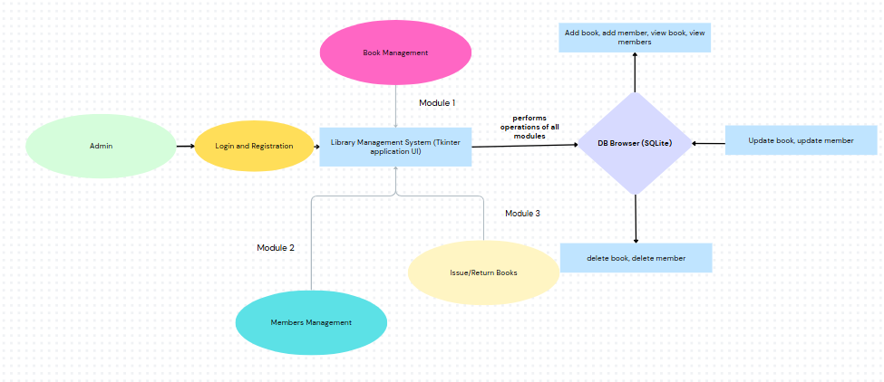

**Conclusion**

The Library Management System developed using Tkinter and SQLite provides an efficient and user-friendly solution for managing a library's operations. This system allows for the seamless management of books, members, and transactions, significantly reducing the manual workload of librarians and enhancing the accuracy of records. The system's modular design ensures that it can be easily adapted or expanded to accommodate future needs, such as integrating more advanced features like automated reminders for book returns or incorporating digital content management. By automating core functions such as issuing and returning books, tracking transactions, and searching records, the system minimizes human errors and optimizes library management.

Moreover, the use of Python and Tkinter for the interface ensures that the system is both responsive and easy to navigate, making it accessible to users with varying levels of technical expertise. The integration of SQLite as the database engine provides a robust and lightweight solution for data storage, allowing the system to handle a substantial amount of data while maintaining high performance. The project's structure, with clear objectives and a well-defined architecture, aligns perfectly with the needs of a modern library, paving the way for further enhancements and scalability.

Overall, this system not only meets the current requirements but also establishes a foundation for future improvements, ensuring that it remains a valuable tool for libraries aiming to streamline their operations and improve service delivery to their users.